 | Purpose | Result | Performance
  Component
 | Detects rain and triggers cloth retraction | Accurately identifies rainfall conditions | High sensitivity; may require maintenance to avoid false readings due to dust or debris.
  Rain Sensor
LDR Sensor | Detects sunlight for drying purposes | Provides accurate light intensity measurements | Reliable within standard lighting conditions; limited in extreme weather.
Servo Motor | Automates the movement of the clothesline | Ensures smooth extension and retraction of clotheslines | Operates efficiently; performance depends on motor calibration and load weight.
NodeMCU (ESP8266) | Processes sensor data and controls actuators | Handles all operations and connects to the IoT platform | High processing efficiency; dependent on stable power and WiFi connectivity.
Blynk IoT Platform | Enables remote monitoring and control | Sends notifications and displays real-time data | Great for remote access; requires consistent internet connectivity.

Node MCU
esp8266
Rain Sensor Module

Clothes Line
Servo Motors
Power
LDR

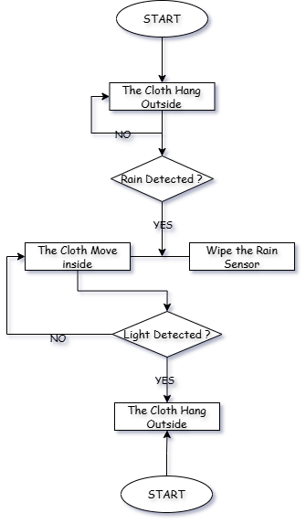

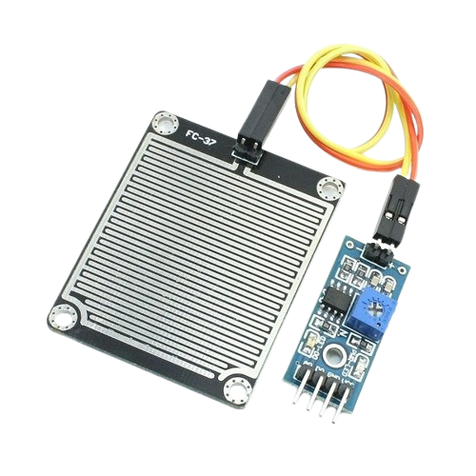
Rain Sensor
LDR Sensor

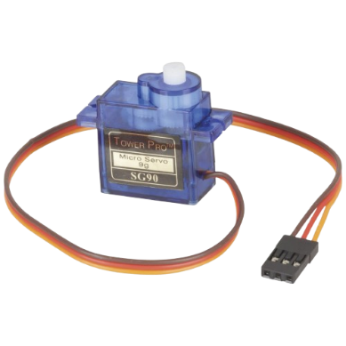
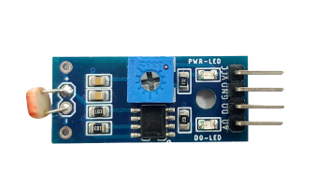
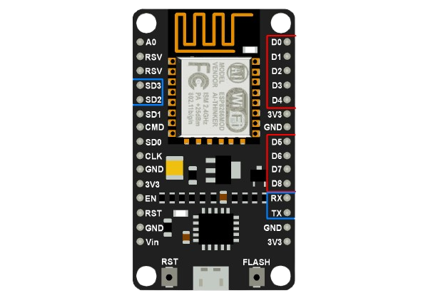
Servo Motor
Servo Motor

